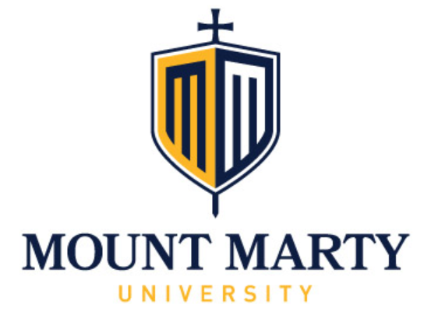
Sacred Heart Endowed Chair Symposium
Slavery in the Land of the Free: Insights on Human Trafficking & Modern Day Slavery
Theresa Flores
November 19, 2020
Overall Objectives: The Learner will be able to learn how prevalent Human Trafficking is in the US, a survivor’s story, and the personal and evidence-based therapeutic recommendations on restoring victims.
Schedule & Objectives:
7:30-8:00 Registration (Vendors, Book Purchase, & Research Displays)
8:00-9:00 Human Trafficking 101
Objective: To know how prevalent human trafficking is in the US. The statistics & places it happens as well as WHY this is occurring.
9:00-10:00 Physical and Emotional Implications of Human Trafficking upon a Victim & The mindset of a Victim and Post-Traumatic Stress Disorder (PTSD)
Objectives: Learn what can happen to a Victim physically & emotionally when they are trafficked. Why does a victim stay in this & not reach out for help? Learn why they stay silent.
10:00-10:15 Break (Vendors, Book Purchase, & Research Displays)
10:15-11:15 Learn what perpetuates Human Trafficking & how Demand for sex for sale is here is different than other countries & Learn what our laws are doing about Human Trafficking
Objective: Demand-Why Human Trafficking is this prevalent and the Law.
11:15-12:15 Lunch on Your Own & Book signing opportunity
12:15-1:15 Therapeutic recommendations & The SOAP Project & Other Resources
Objective: What can be done? Recommendations based Evidence Based Practice to prevent trafficking as well as how to treat & restore Victims.
1:15-1:35 Call to Freedom
Objective: Learn about SD resources and training opportunities
1:35-1:50 Break (Vendors, Book Purchase, & Research Displays)
1:50-2:50 Hear a Victim’s story of how they became Trafficked & What made them vulnerable & Discussion about Story
Objective: Theresa’s Story
2:50-3:00 Online Evaluation, Book signing opportunity, & Adjourn
Available to purchase at the Event: Slavery in the Land of the Free by Theresa Flores

